# Week 2

1. Downloaded MongoDb Compress and installed

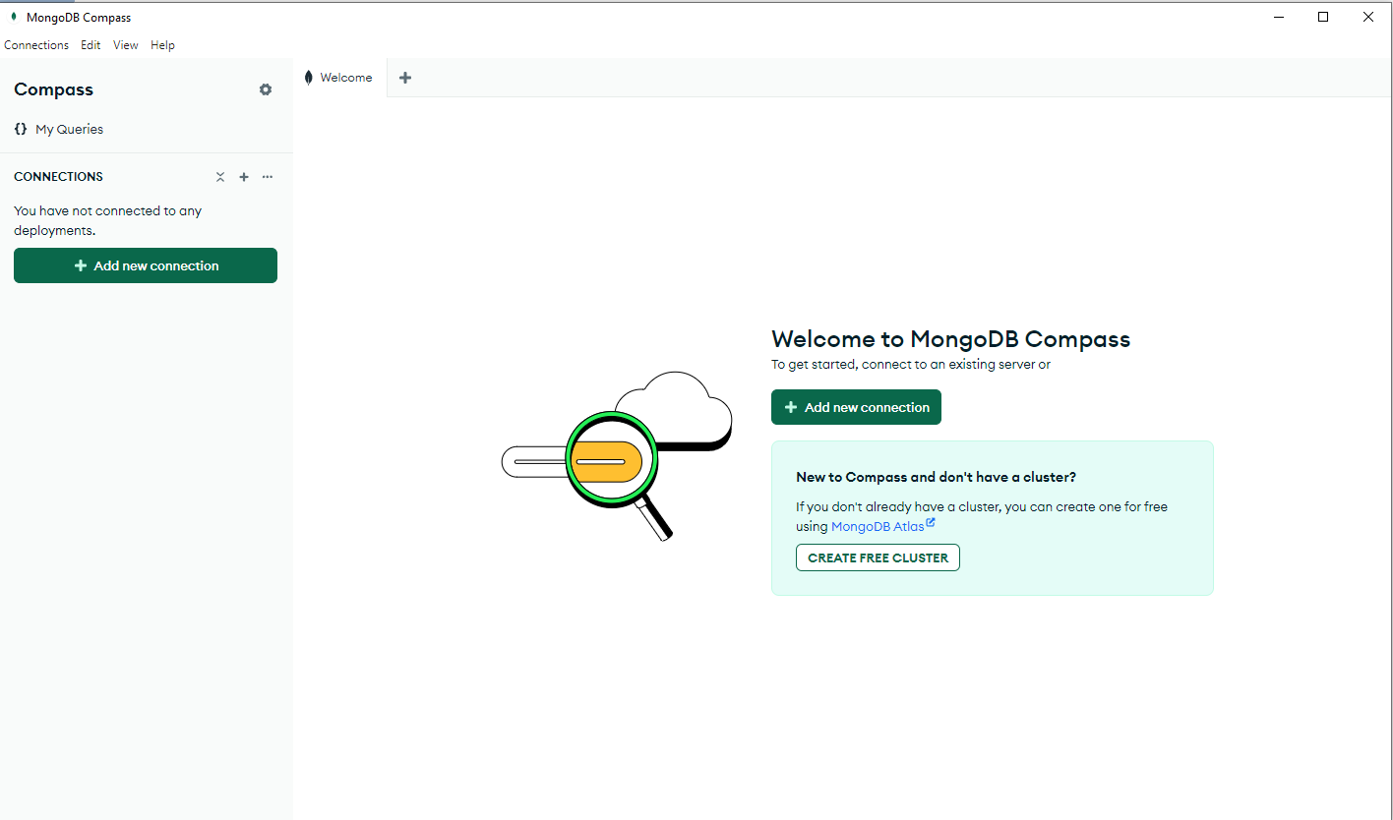

2.Created a connection with **localhost**

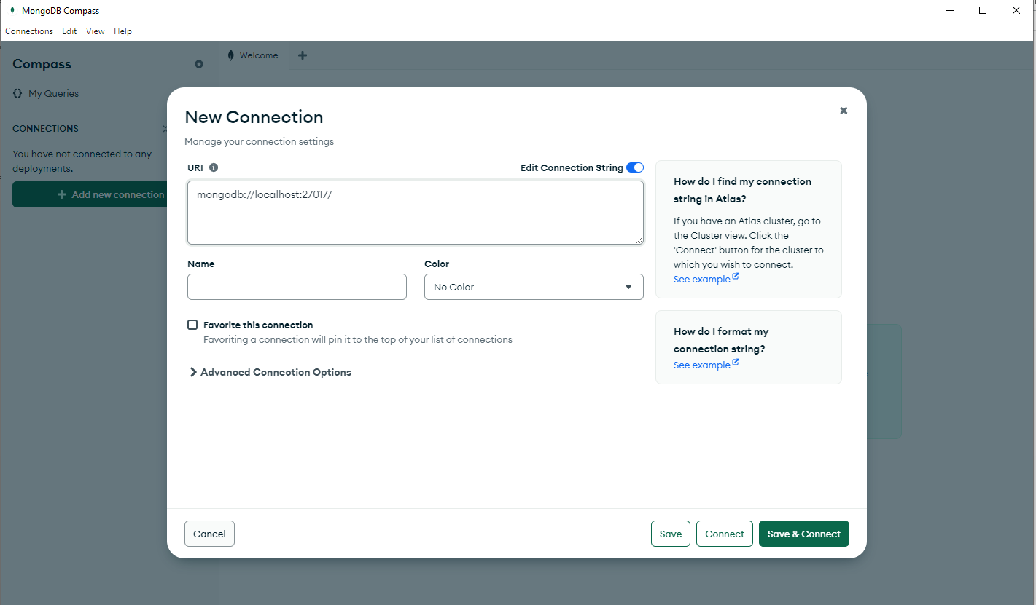

1. Created a database of **peopledb** with collection of **people**

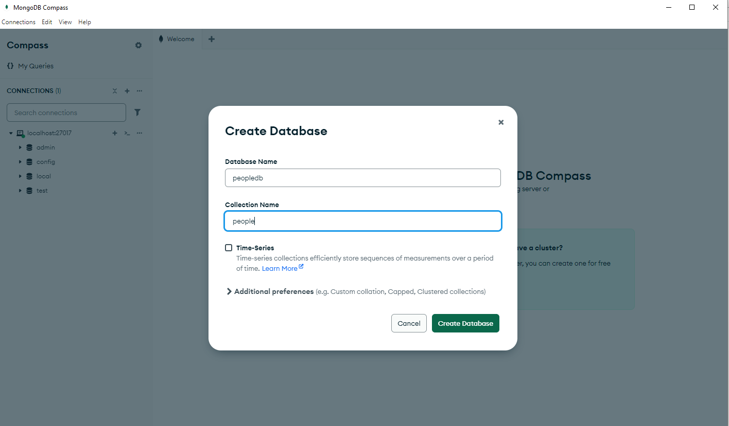

1. Database and collection created successfully

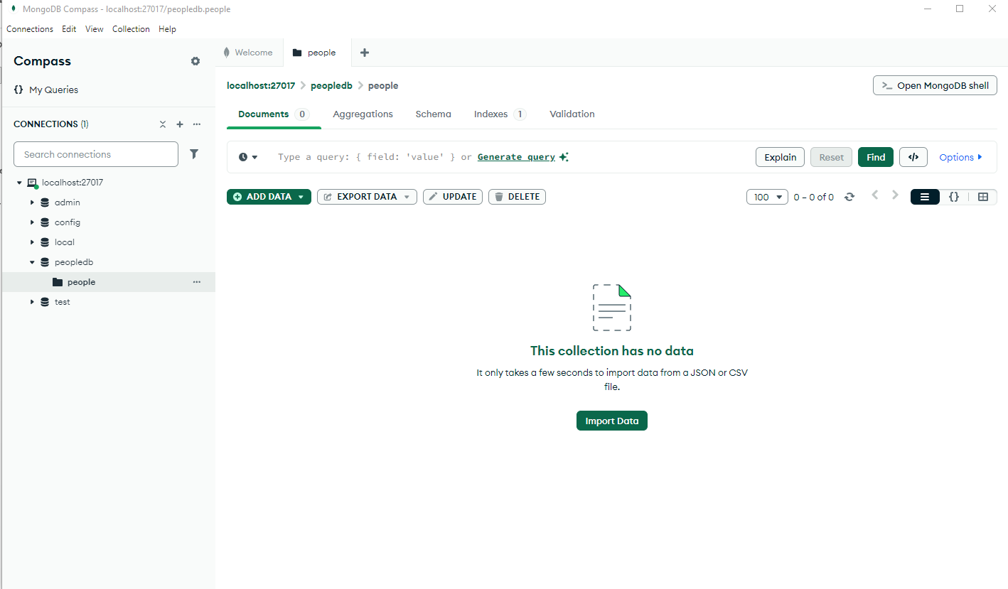

5. Imported csv data into mongodb compess  
  
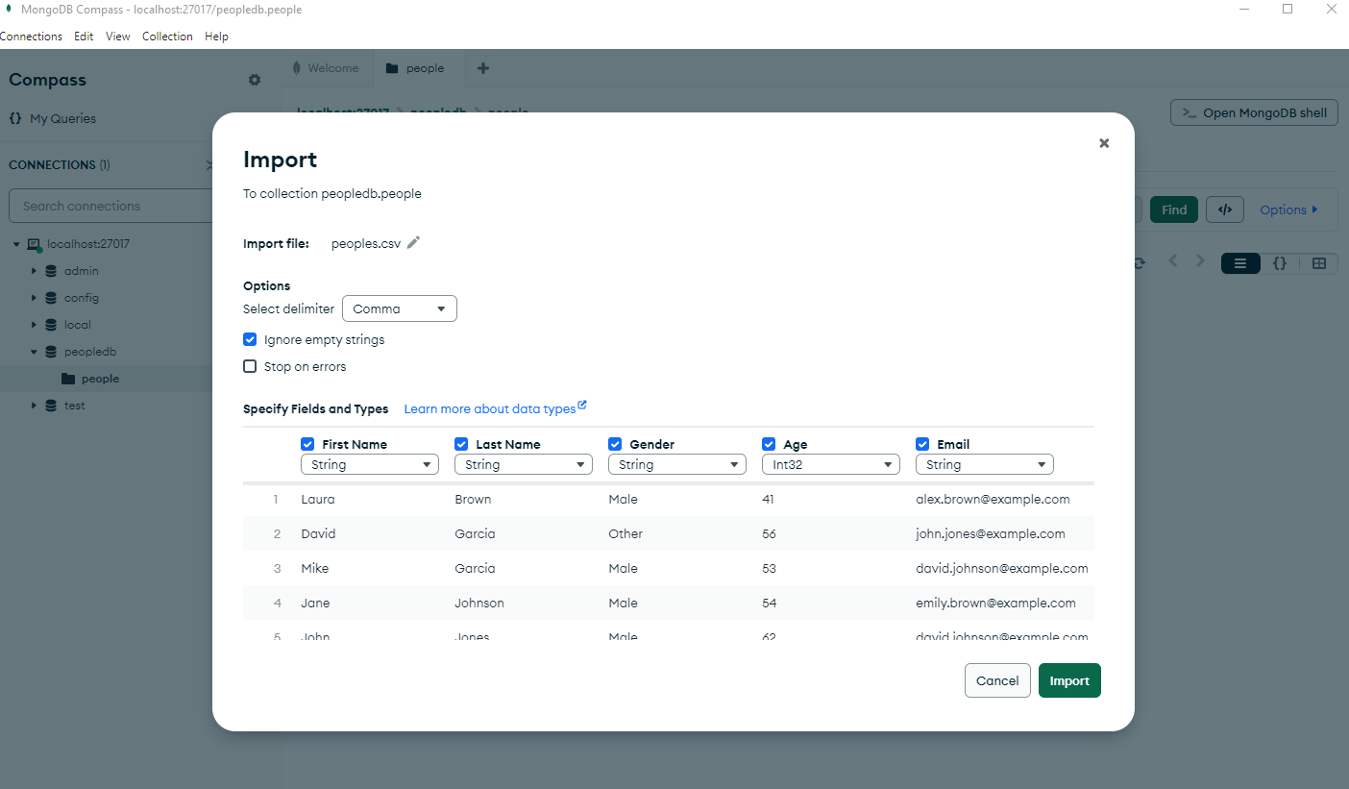

**Lab Task**

1) Repeat the same process to search Education for Master and .Find the avg,min,max age and avg min max Salary of the people group by Marital status.

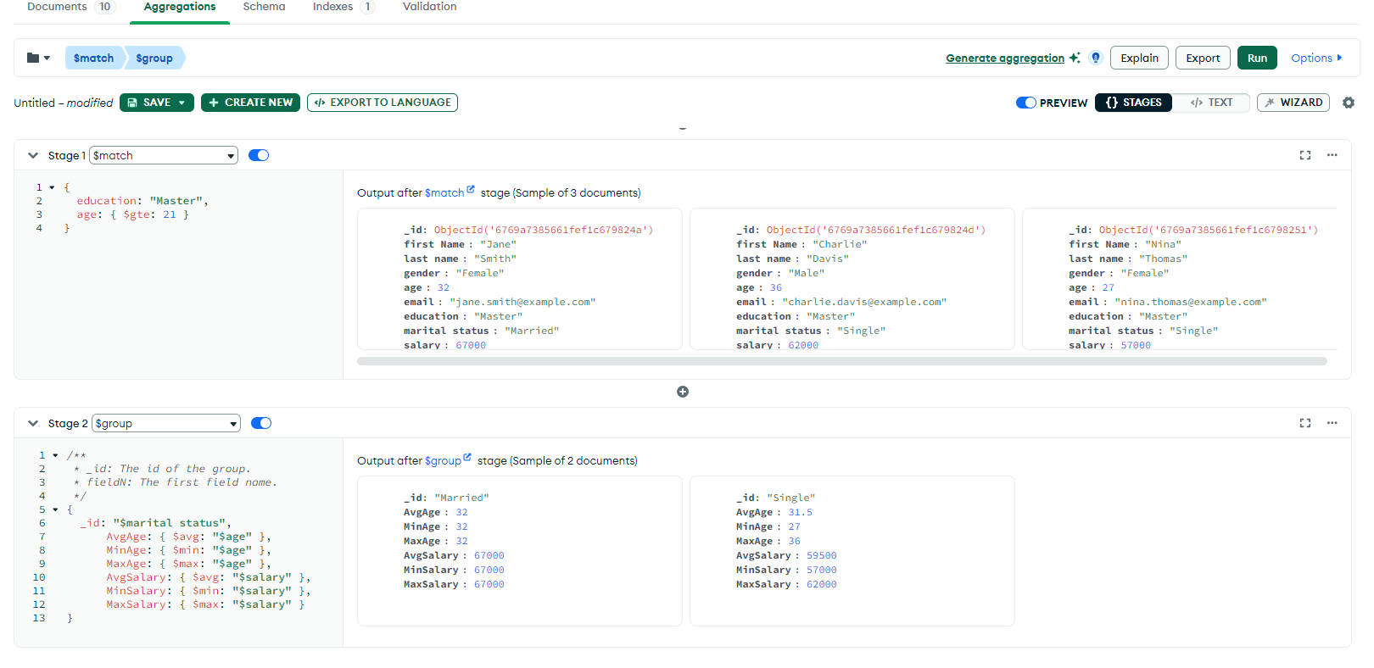

2) find min,max average salary of each age group of female

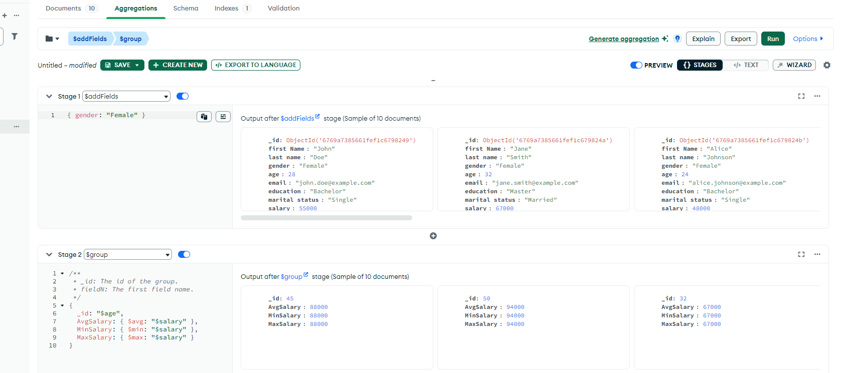

3) Find min, max, average salary of each age group of males

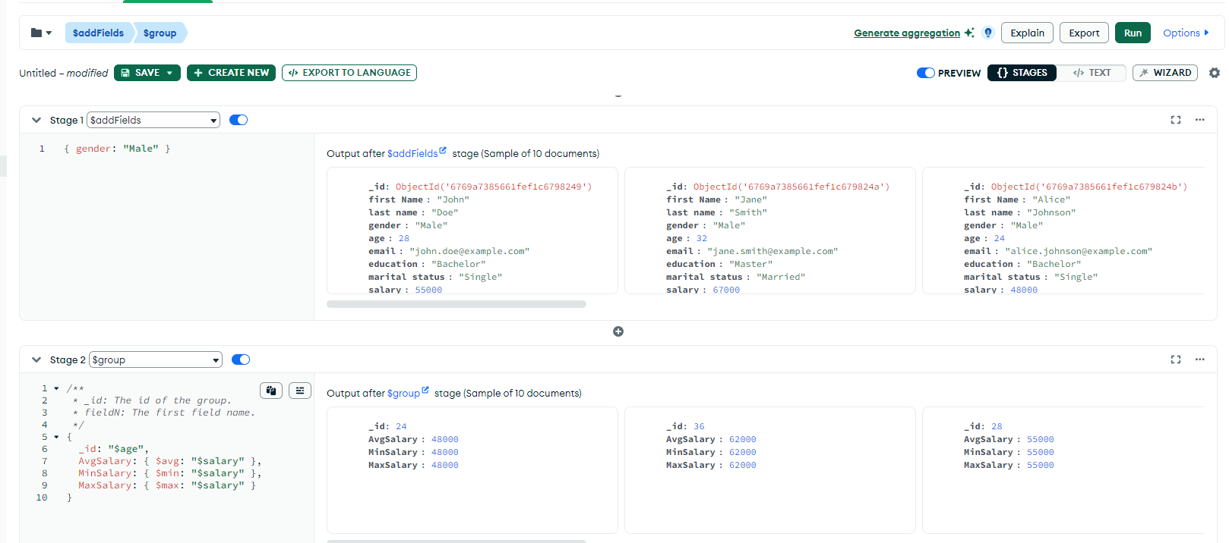

4) Count married and unmarried females and males.  
